**Batch: D2 Roll No.: 16010221032**

**Experiment / assignment / tutorial No. 10**

**Grade: AA / AB / BB / BC / CC / CD /DD**

**Signature of the Staff In-charge with date**

|  |
| --- |
| **TITLE:**  Application oriented program: Find impedance of series and parallel RLC Circuit |

**AIM:** Program to find unknown impedance of RLC circuit and represent the result in both polar and rectangular coordinate system

**______________________________________________________________________**

**Expected OUTCOME of Experiment:**

1. Formulate a problem statement and develop the logic (algorithm/ flowchart) for its solution
2. Apply basic concepts of C Programming for problem solving
3. Illustrate the derived and structured data types such as arrays, strings, structures, and unions.
4. Design modular programs using functions and demonstrate the concept of pointers and file handling.

**_____________________________________________________________________**

**Books/ Journals/ Websites referred:**

1. Programming in C, second edition, Pradeep Dey and Manas Ghosh, Oxford University Press.
2. Programming in ANSI C, fifth edition, E Balagurusamy, Tata McGraw Hill.
3. Introduction to programming and problem solving , G. Michael Schneider ,Wiley India edition.

**_____________________________________________________________________**

**Problem Definition:**

For a given RLC Circuit and frequency, find the impedance of individual components. Use the formula to calculate total impedance of the circuit, first for series, and next for parallel RLC circuit. Now change the frequency in steps, tabulate the result and comment on the impedance value.

**For Series R-L-C**

Z

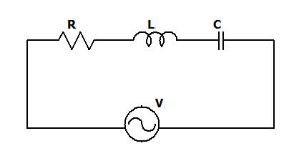

If XL > XC where

Ω

Ω

**For Parallel R-L-C (R, L and C connected in parallel)**

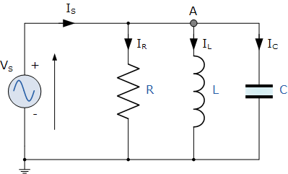

**Implementation details:**

**#include <stdio.h>**

**#import <math.h>**

**void main()**

**{**

**int frequency; //take input**

**int capacitance; //take input**

**int inductance; //take input**

**int resistance; //take input**

**int choice; //take input - switch case**

**float omega; //for calculation of impedance**

**float Z; //final answer**

**int temp; //temporary**

**float theta; //for trigo calculation to find ZT**

**float Zt; //total impedance**

**//calculate Z**

**printf("Enter the capacitance of the capacitor: ");**

**scanf("%d", &capacitance);**

**printf("Enter the inductance of the inductor: ");**

**scanf("%d", &inductance);**

**printf("Enter the resitance of the resistor: ");**

**scanf("%d", &resistance);**

**printf("Enter the frequency of the AC input: ");**

**scanf("%d", &frequency);**

**printf("Your circuit in series or parallel connection: \n");**

**printf("1. Series Connection\n");**

**printf("2. Parallel Connection\n");**

**scanf("%d", &choice);**

**switch (choice)**

**{**

**case 1:**

**printf("\\\\**Series connection**//\n");**

**omega = 2 * 3.14 * frequency;**

**float XL = omega * inductance;**

**float XC = 1 / (omega * capacitance);**

**temp = XL - XC;**

**Z = (resistance*resistance) + (temp * temp);**

**Z = sqrt(Z);**

**theta = temp/resistance;**

**theta = atan(theta);**

**Zt = Z * theta;**

**printf("The value of impedance is: %f\n", Z);**

**printf("The value of total impednace is: %f\n", Zt);**

**printf("The value of total impedance in polar format is: [%d + j %d]\n" , resistance, temp);**

**break;**

**case 2:**

**printf("\\\\**Parallel connection**//\n");**

**omega = 2 * 3.14 * frequency;**

**float YR = 1/resistance;**

**float YL = 1/ omega * inductance;**

**float YC = omega*capacitance;**

**temp = YL - YC;**

**Z = (YR*YR) + (temp*temp);**

**Z = 1/ sqrt(Z);**

**theta = temp/resistance;**

**theta = atan(theta);**

**printf("The value of impedance is: %f\n", Z);**

**break;**

**default:**

**printf("\nEnter a valid choice next time. ");**

**break;**

**}**

**}**

**Output(s):**

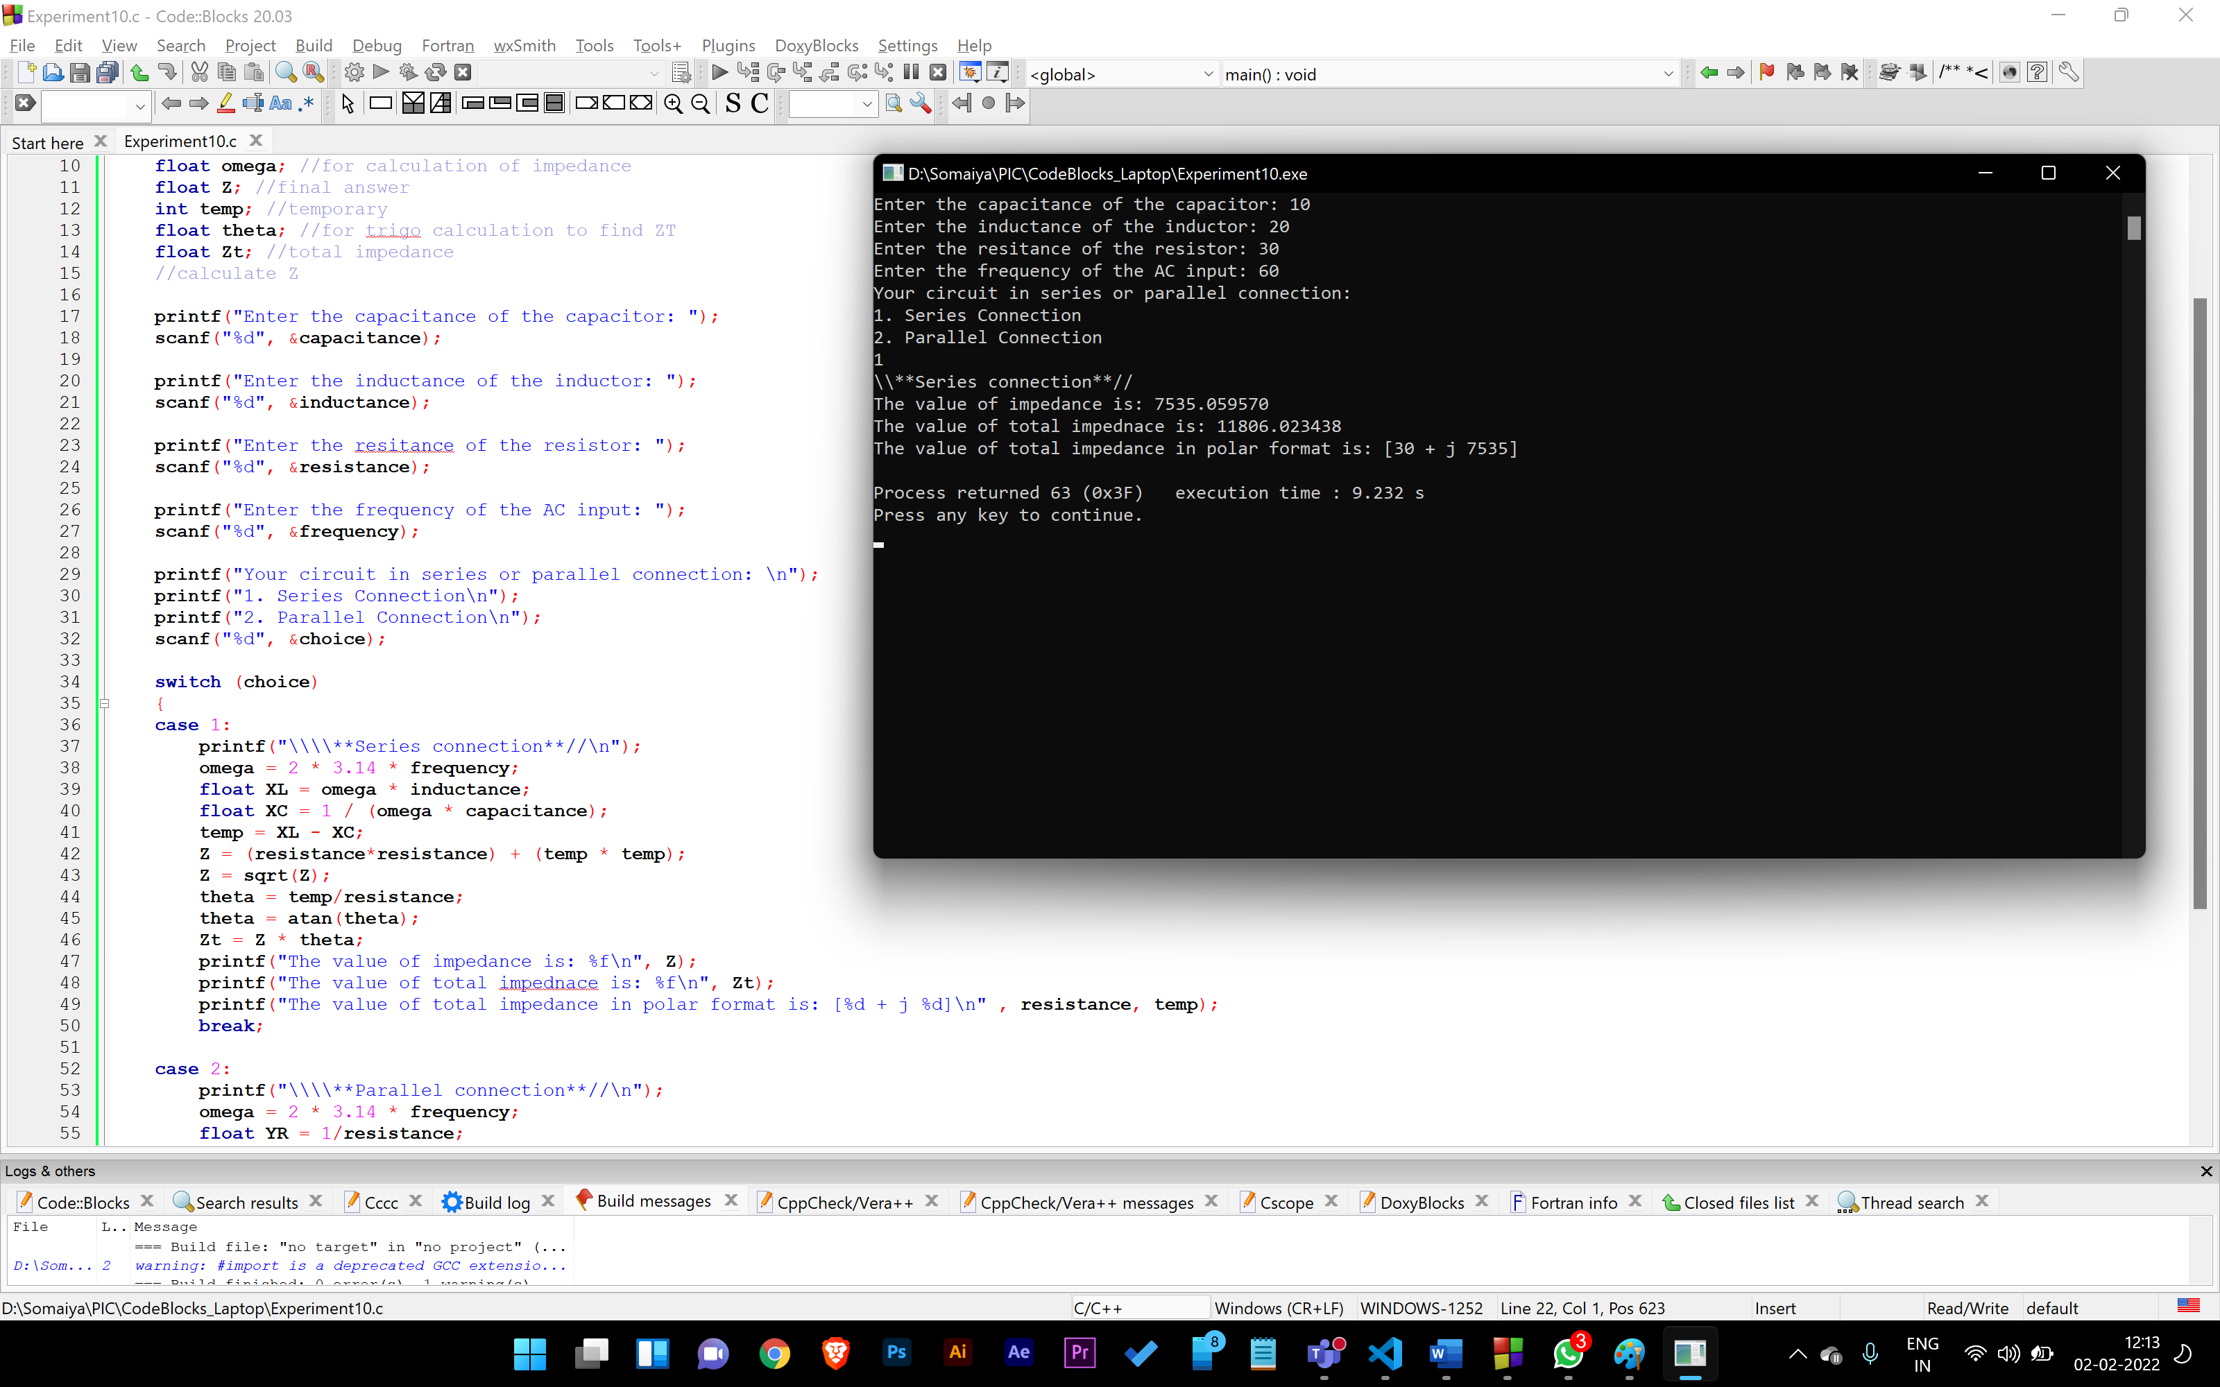

**Conclusion:**

**We learn to apply coding into real life application problems.**

**Post Lab Descriptive Questions**

**Change the above program to find the following quantities.**

1. **pf =**
2. **Active power**
3. **Reactive power**

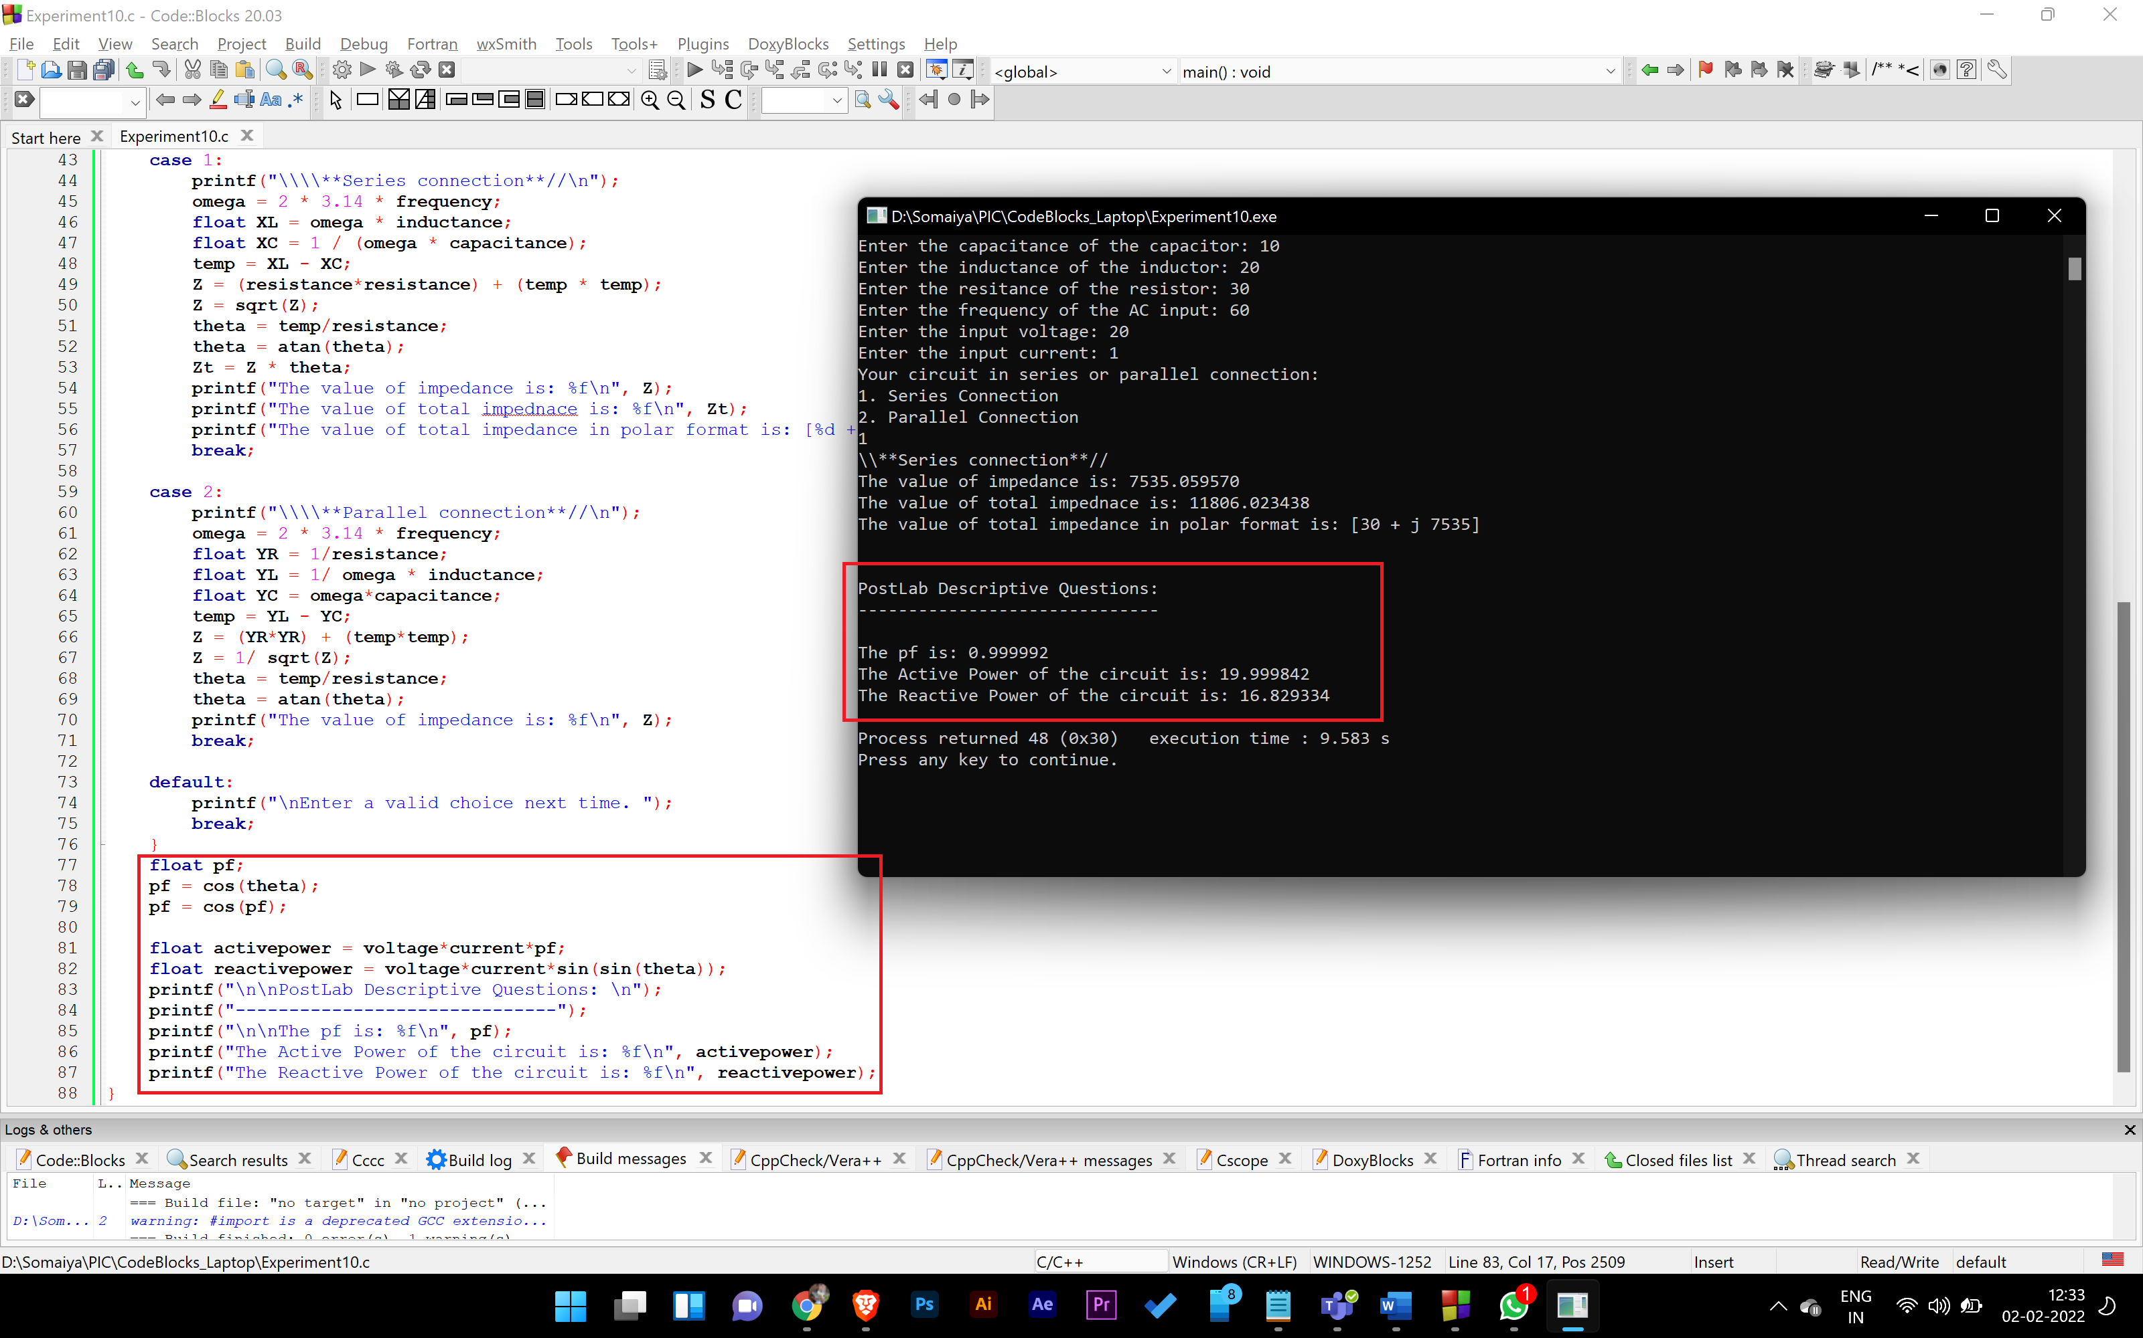

**Date: _____________ Signature of faculty in-charge**